**FEBRUARY FULL STACK DEVELOPMENT TRAINING**

**------------------------------------------------------------------------------01/02/2025 Saturday**

1)Variables:

Let, var, const ;

2)Operations

3)Conditional Statements

4)loops

5)functions

6)OOPS,DataStructures

7)Ap,V,C

8)promises

**JavaScript Revision Practice questions:**

**Scenario 1 :**you are tasked with building a system to check whether a person is eligible to vote.The system follows these rules:

1.A person must be at least 18 years old to vote.

2.If the person is a citizen ,they are eligible to vote.

3.If the person is not a citizen but has passed a citizenship test,they are eligible to vote.

4.If the person is under 18,they cannot vote.

**Code:**

let age = prompt("Enter the age");

      let citizen = prompt("Enter the citizenship");

      let cTest = prompt("Citizenship result");

      if (age >= 18 && (citizen == "Indian" || cTest == "Passed")) {

        document.write("Can eligible for voting");

      } else {

        document.write("Cannot vote")

      }

**Scenario 2:Discount Eligibility**

An online store offers a discount system based on the following consitions:

1.A customer who spends more than Rs.100 gets a 20% discount.

2.A customer who spends more than Rs.50 but less than or equal to Rs.100 gets a 10% discount.

3.If the customer is a premium member, they receive an extra 5% discount.

**Code:**

      let customer1 = parseFloat(

        prompt("Enter the total amount of bill for customer 1")

      );

      let customer2 = parseFloat(

        prompt("Enter the total amount of bill for customer 2")

      );

      let customer3 = prompt( "Are you a premium member? (yes/no)" ).toLowerCase();

      if (customer1 > 100 ||(customer2 > 50 && customer2 <= 100) ||customer3 === "yes") {

        document.write("You get a 20% discount");

      } else {

        document.write("You get a 10% discount");

      }

**-----------------------------------------------------------------------------------05/02/2025 Tuesday**

To create a element by React js:

---React.createElement(‘h1’);

**Syntax:**

React.createElement(‘h1’)

-type = tag name (div,h1,p)

Props = className,id,onClock

--to display the element

--ReactDOM.createRoot()

--ReactDOM.render() --to display the element

**Syntax:**

Reactelement -what to render

Container = where to render

**Intro to JSX:**

(JavaScript XML) is a syntax extension for js in react js;it allows us to write html code in react.

--make us easier to write Html in react.

**JSX**:JSX code gets compiled into JS

Babel:a tool converts translates into js

**Keypoints;**

<br/>

Using function call

**------------------------------------------------------------------------------05/02/2025 wednesday**

--ReactDOM.createRoot();

--render

**JSX:**

Javascript XML is a syntax extension for JS:

It allows us to write HTML code in React

The JSX code gets compiled into JS

**Babel:**A tool converts HTML code in JS

--All the html tags must be closed

**---------------------------------------------------------------------------------06-02-2025 Thursday**

#empty folder

#npx-nope package executor

create react app

-npx create-react-my-app #here my-appp is our project name

cd my-app #change directory(folder)

npmm start #to startthe react application

**Public/index.html:**

The main html file that serves as the entry point for the app.

**Src/index.js:** The js entry point for the react app where the DOM is rendered

**Src/App.js:** The main component that serves as the root of the component tree

**Src/components:** A folder to store reusable components

1)components core building blocks of a react application)

->The help to create reusable block of code

->If an thing goes wrong in UI, it is very easy

**----------------------------------------------------------------------------------07/02/2025 Friday**

**Components:**

**Conditional Rendering:**

If , else:

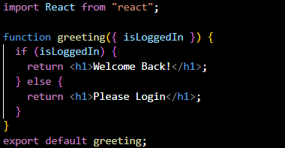**App.js: greeting.js:**

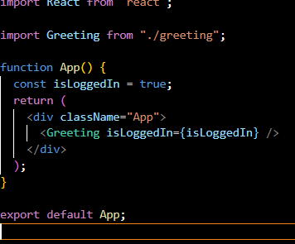

#error-scripts disabled-command;set

#web vitals --- npm install web-vitals

**#lists and keys:**

In Reat,a list is a collection of items you want to show on screen

**#keys:** Keys in react helps us to keep the track of items in a list

->React know which items you have changed; updated

**Map():** elements in array

--function will be applied to all elements

Const n=[1,2,3,4,5]

Const d = n.map(num =>num*2)

Console.log(d)

#2,4,6,8,10

#map() in react for lists:

**App.js:**

